YOLO-Lite 卷积测试报告

本文档记录使用Mini Davinci通用型卷积神经网络加速器对YOLO-Lite卷积神经网络中的卷积、池化层进行simulation实测的结果。

|  |  |  |  |  |
| --- | --- | --- | --- | --- |
| **YOLO-Lite Network Shape** | | | | |
|  | Input | Output | In channel | Out Channel |
| CONV-0 | 226 | 224 | 3 | 16 |
| POOL-0 | 224 | 112 | 16 | 16 |
| CONV-1 | 114 | 112 | 16 | 32 |
| POOL-1 | 112 | 56 | 32 | 32 |
| CONV-2 | 58 | 56 | 32 | 64 |
| POOL-2 | 56 | 28 | 64 | 64 |
| CONV-3 | 30 | 28 | 64 | 128 |
| POOL-3 | 28 | 14 | 128 | 128 |
| CONV-4 | 16 | 14 | 128 | 128 |
| POOL-4 | 14 | 7 | 128 | 128 |
| CONV-5 | 9 | 7 | 128 | 256 |
| CONV-6 | 7 | 7 | 256 | 125 |

The stride is 1. Kernel size of CONV-6 is 1. Kernel size od the other CONV layers is 3.

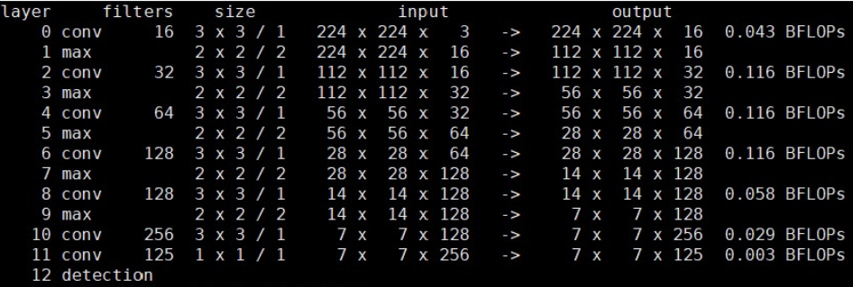

测试结果如下。

Ideal time的计算方法为：

Ideal time = ofmap_size^2 × ksize^2 × ifm_chn × ofm_chn÷512（the number of DSP）

|  |  |  |  |
| --- | --- | --- | --- |
|  | Ideal time | Real time | Efficiency |
| CONV-0 + POOL-0 | 42336 | 236097 | 17.93% |
| CONV-1 + POOL-1 | 112896 | 178915 | 63.1% |
| CONV-2 + POOL-2 | 112896 | 150299 | 75.11% |
| CONV-3 + POOL-3 | 112896 | 135451 | 83.35% |
| CONV-4 + POOL-4 | 56448 | 77240 | 73.08% |
| CONV-5 | 28224 | 65800 | 42.89% |
| CONV-6 | 3062 | 30344 | 10.09% |
| Total | 468758 | 874146 | 53.62% |

将数据初始化入BRAM中，DLA通过Native接口读取BRAM中数据。